DISC & Motivators
Understanding what motivates us, what inspires us, and is deemed important by us is
a vital first step in self-awareness and improving human performance and
effectiveness. Knowing our specific level of motivation can be crucial to helping us
understand what drives our beliefs and actions so we can bring them into alignment.

Using DISC & Motivators together provides
new perspective to enhance self-awareness.

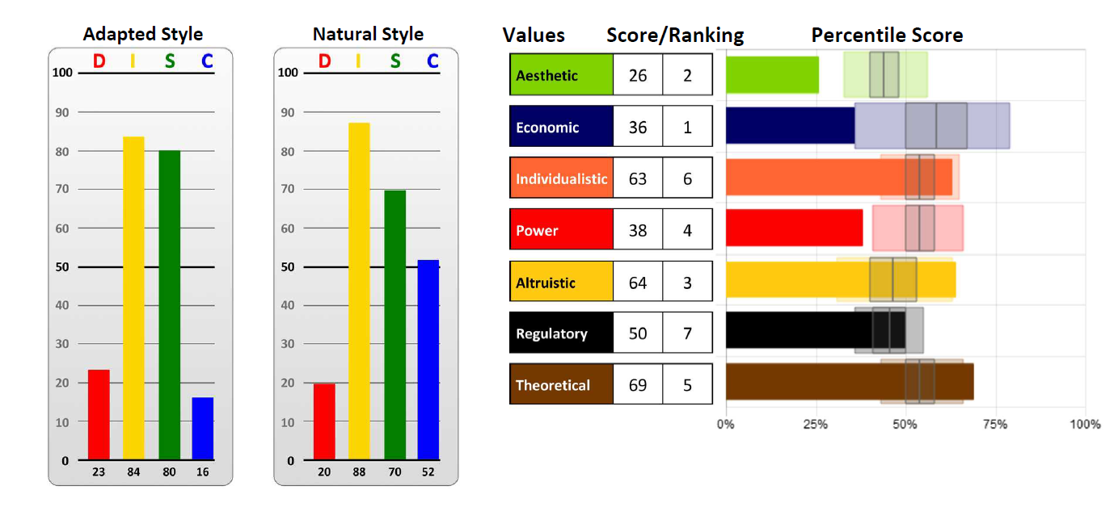

DISC Styles focuses on patterns of external, observable behaviors
using scales of directness and openness that each style shows. Because we
can see and hear these behaviors, it becomes much easier to read people. It
is simple, practical and easy to remember and use.

Motivators help people to better understand their unique value hierarchy or
belief system pertaining to what motivates them, what they are most drawn to
and where their passions lie.

Key Information
- Behavior (how we act) is determined by emotion (how we
feel). Motivators are the reasons that drive us to want to
act. These cannot be separated, only distinguished.

- Behaviors can ONLY reveal likelihoods of Motivation.
Motivators can ONLY reveal likelihoods of Behavior.
Neither alone can give a complete picture of how someone will behave or what may motivate them, but together, we can get a much clearer understanding of how a person will likely behave and why.

- The DISC styles and Motivators do have relationships – high and low scores for some align directly, but not always.
D style typically aligns with Economic and/or Power
I style typically aligns with Individualistic and/or Power
S style typically aligns with Altruistic
C style typically aligns with Regulatory
Regulatory and Aesthetic can align with any DISC style.

- How can I use DISC & Motivators to grow my business?
- How can I use DISC & Motivators to more adequately coach and train my clients and customers?

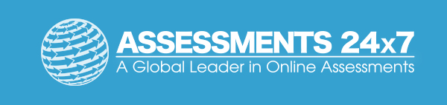Assessments 24x7 LLC 5927 Balfour Court, Ste. 103 Carlsbad, California 92008 USA (206) 400-6647

